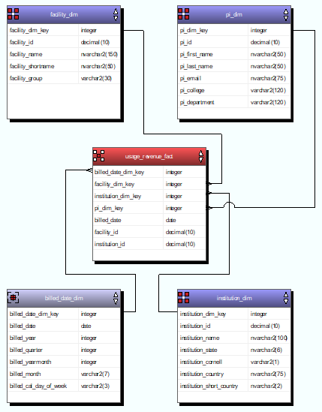
By checking Display Data for each step, I think all needed tables in place and the names match the instructions. All tables populated and the data transformations work correctly.

